Skin Graph-t 6/25/15

This is very complete and well-written, especially given that you were so pressed for time.

Problems 2 and 3 in particular are clear and correct proofs. Keep up the good work!  
--RK

Technical Writer: Dean Gladish

Engineer: Charlie Goldschmiedt

Conductor: Charlie Goldschmiedt

Reporter: Mitchell Mikinski

Morning Session: This morning we spoke about a variety of topics. We spoke about Vertex connectivity, partitions, the theorem that states; a graph is bipartite if and only if it contains no odd cycles, chordal graphs, and also did 4 morning problems.

1. Yes. Ex- O← A

← B (empty set)

* Please explain what the picture means in the future, it was confusing, but, your answer is not a counter example. - Lizzy

1. In order for a graph to be Eulerian, it must be connected and even-degreed. It must contain a closed Eulerian trail that returns to the initial vertex. If we say that the initial vertex of a bipartite graph is in set A, returning to the initial vertex requires two steps as the continuous path must alternate between set A and B. As a result, a graph that returns to the initial vertex would have a number of edges that is a multiple of two. Therefore, a graph that is both Eulerian and bipartite would have an even number of edges.

Excellent! I know you worked hard on this proof, and it shows. The argument is clear and convincing. As a slight clarification, the “continuous path” you’re talking about is actually a trail; a “path” can’t repeat vertices, but a “trail” can.

--RK

1. no answer
2. A graph is bipartite if and only if it can be partitioned into 2 independent sets. If this bipartite graph was a marriage graph, and there are only two genders, we can gather that the two independent sets represent the two genders. The independent sets would be defined as Male and Female. Since the graph is bipartite, that means a male would not be connected to another male, mutatis mutandis. That would mean this graph would have marriage defined between one man and one woman. However, our graph is not bipartite. That means that males would be married to males, and females to females. In Michigan, this is illegal, meaning that this can’t happen. Thus, this non-bipartite marriage graph can’t be a Michigan Marriage Graph. ***Q.E.D***

* Fantastic explanation, and its correct, darn Michigan falling behind on progress. Good job with this one. - Lizzy

1. A)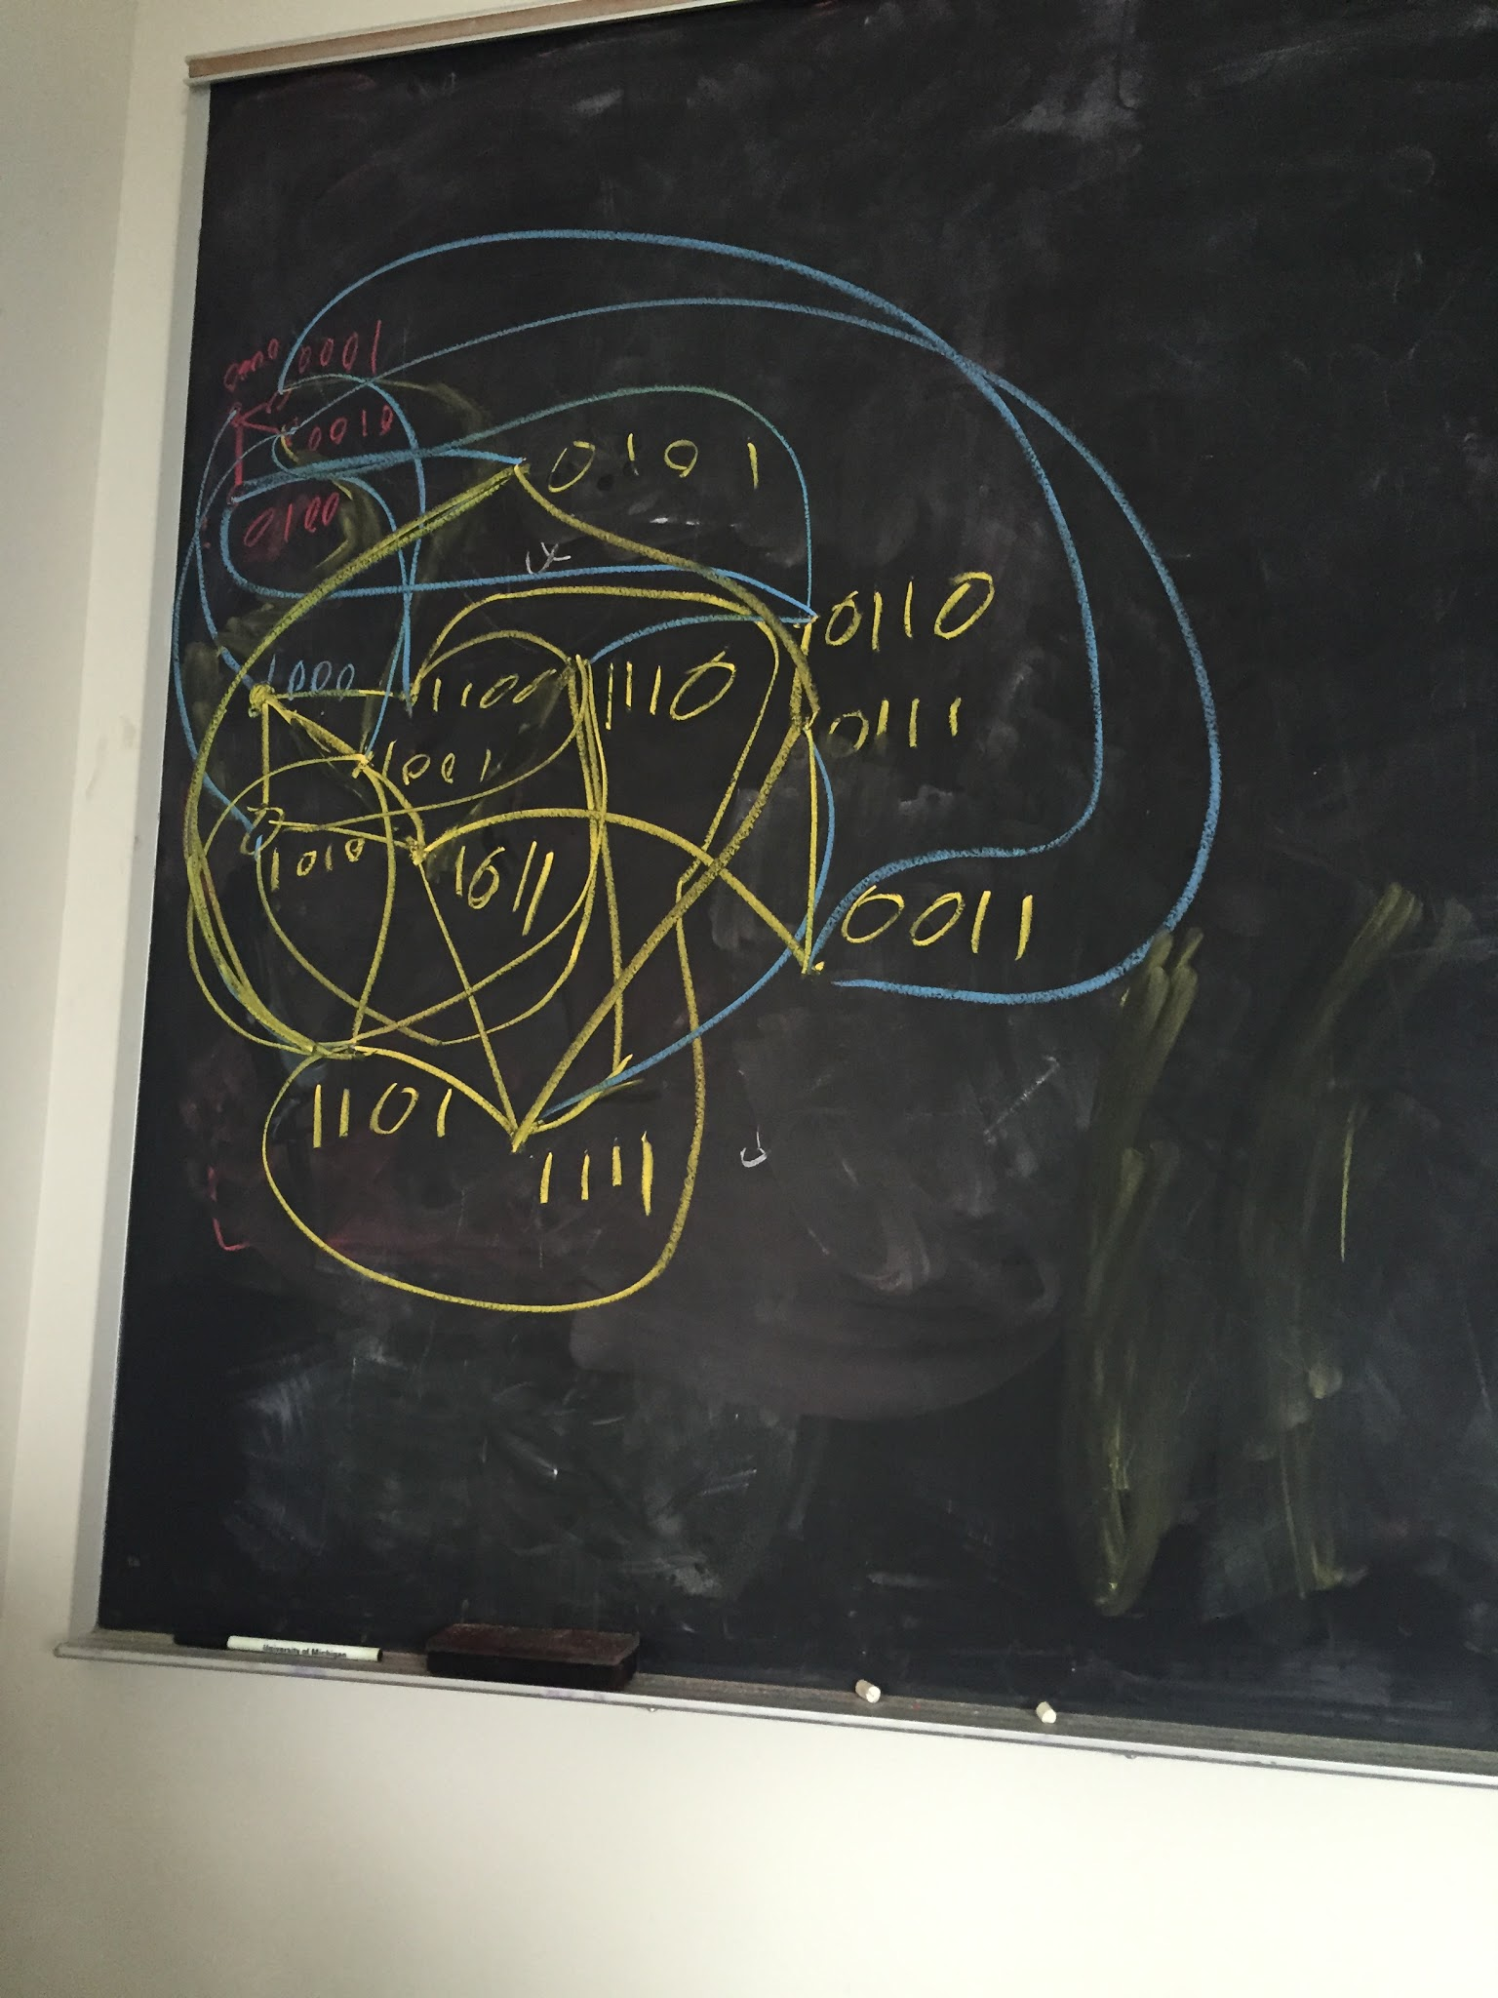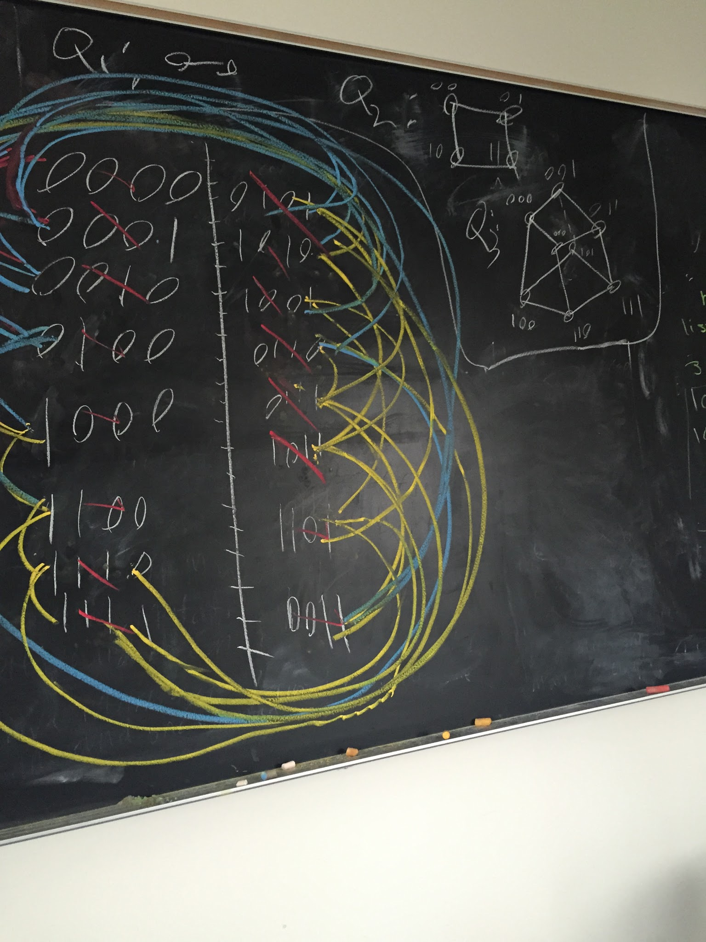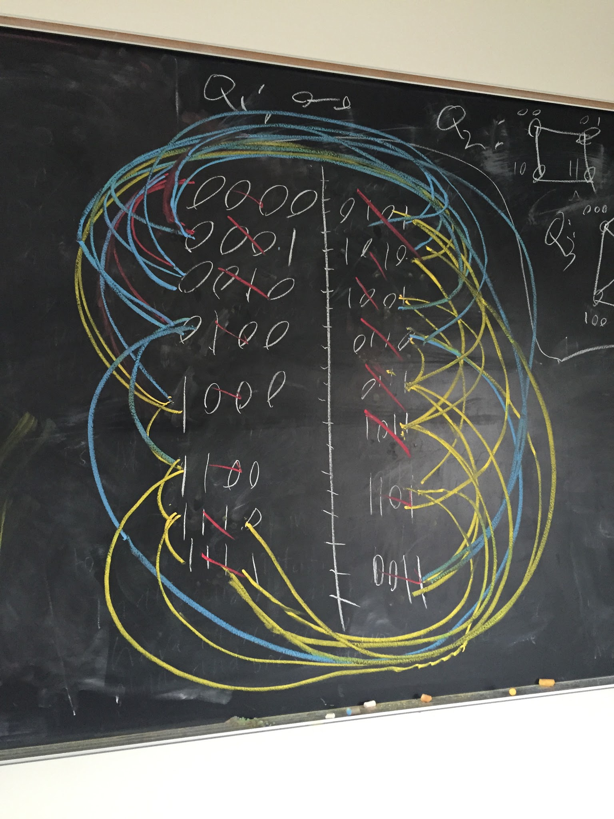

* Youre missing Q1, Q2, Q3, and your Q4 four should have been drawn more clearly, it's really messy and hard to check if it's right or not. - Lizzy

b). Assume Qn is not regular. Create n tuples. In order to create a graph of n tuples, each vertex must be connected to every ( n-1 vertices) [Im not sure what you mean by this?.] They all would have this same property. Thus, Qn graphs would be regular. QED

* A much better attempt at writing a mathematical answer, a few more kinks, but, improvement nonetheless. - Lizzy

6)

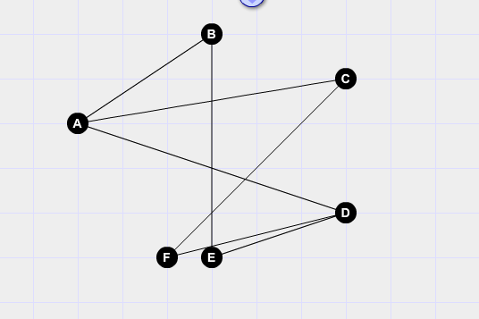

In the chordal graph, we have a cycle A,B,E,D,F,C

In the interval graph, A overlaps C and D, but C and D do not overlap. This would mean that C and D are situated on opposite ends of A in the interval graph.

F overlaps both C and D. In order for this to be possible, F would have to overlap A. This contradicts the original graph, in which F does not connect to A. Therefore, the chordal graph cannot be translated into an interval graph.

You explained your thinking on this problem very well. I like the way you defined and explained your notation, and also your clearly-labeled diagram. Very impressive. Your argument that the graph above is not an interval graph is completely correct. However, the graph you drew isn’t chordal! For example, the vertices ABED give a 4-cycle which doesn’t have a chord--can you see why?--RK  
